To be a scout you will need to learn a few things and abide by the scout law and promise.
You will need to know these when you are invested.
There may be times when we need to reflect on these to help us being the best scouts in town!

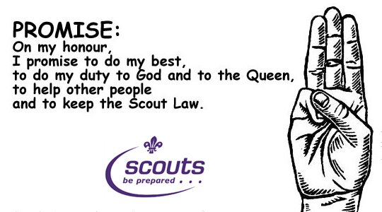

The Scout Law
- A Scout is to be trusted.
- A Scout is loyal.
- A Scout is friendly and considerate.
- A Scout belongs to the world-wide family of Scouts.
- A Scout has courage in all difficulties.
- A Scout makes good use of time and is careful of possessions and property.
- A Scout has self-respect and respect for others.

